National University of Computer & Emerging Sciences, Karachi Computer Science Department
Course Code: SE-3003 | Course : Web Engineering Lab

Spring 2023, Lab Manual – 03
Tailwind CSS

Tailwind CSS is a popular utility-first CSS framework used for building responsive and customizable web interfaces.
It is a popular utility-first CSS framework used for building responsive and customizable web interfaces. It provides a set of pre-designed utility classes that you can apply directly to HTML elements to style and layout your web pages.

Tailwind Setup:
Use the Play CDN to try Tailwind right in the browser without any build step. The Play CDN is designed for development purposes only and is not intended for production.
Follow this link to do play cdn setup:
https://tailwindcss.com/docs/installation/play-cdn
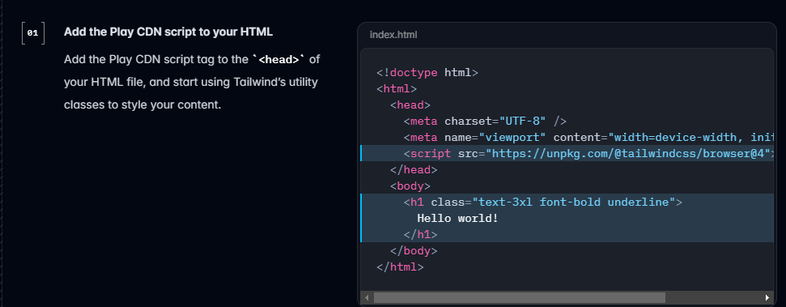
Tailwind comes with built-in utility classes that help you control typography, colors, spacing, borders, and more.
- Text classes: You can change text size (text-xl), color (text-red-500), and weight (font-bold).
- Color classes: Tailwind provides a range of colors like bg-blue-500 for background colors and text-gray-700 for text colors.
- Font classes: Change font size, weight, line height, etc.

Getting Started with Tailwind:
Tailwind classes:
- Typography and colors:
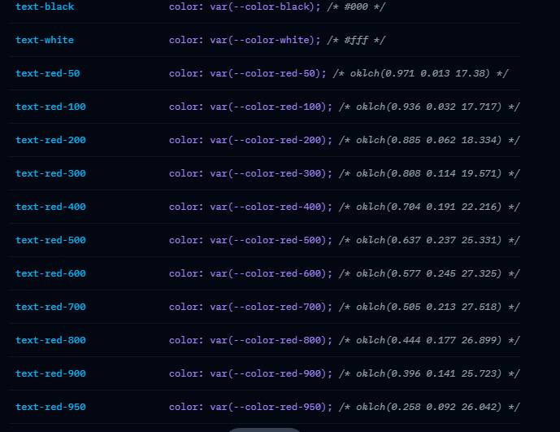

Applying text colors:
<p class="text-blue-600 dark:text-sky-400">The quick brown fox...</p>
Setting Text Opacities:
<p class="text-blue-600/100 dark:text-sky-400/100">The quick brown fox...</p>
<p class="text-blue-600/75 dark:text-sky-400/75">The quick brown fox...</p>
<p class="text-blue-600/50 dark:text-sky-400/50">The quick brown fox...</p>
<p class="text-blue-600/25 dark:text-sky-400/25">The quick brown fox...</p>

Applying text properties on hover:
<p class="..."> Oh I gotta get on that <a class="underline hover:text-blue-600 dark:hover:text-blue-400" href="https://en.wikipedia.org/wiki/Internet">internet</a>, I'm late on everything!</p>

Customizing the theme:
Use the --color-* theme variables to customize the color utilities in your project.
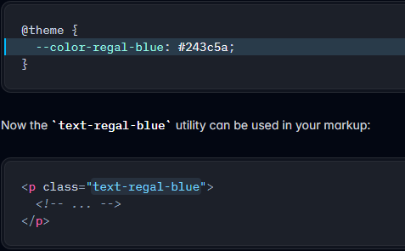

Text Decorations:
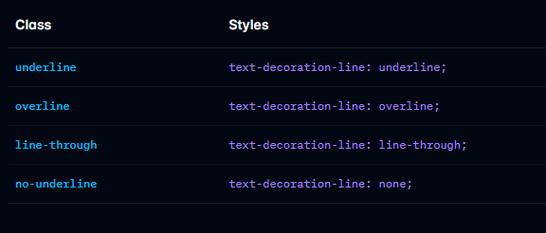
Font Classes:
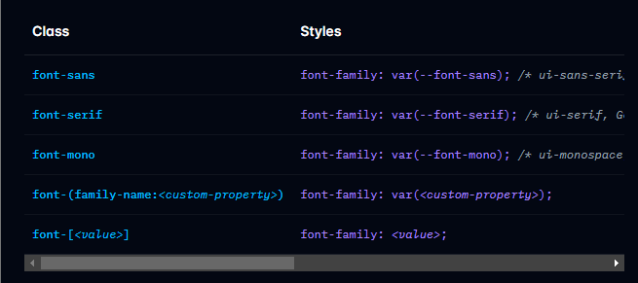
<p class="font-sans ...">The quick brown fox ...</p>
<p class="font-serif ...">The quick brown fox ...</p>
<p class="font-mono ...">The quick brown fox ...</p>

- Typography and colors:

Tailwind simplifies the process of adding spacing between elements using classes like
Padding (p-): Adds space inside an element.
Margin (m-): Adds space outside an element.
You can specify different values like p-2, m-10, and use directional classes like mt-4 (margin-top), ml-8 (margin-left)
Margins:
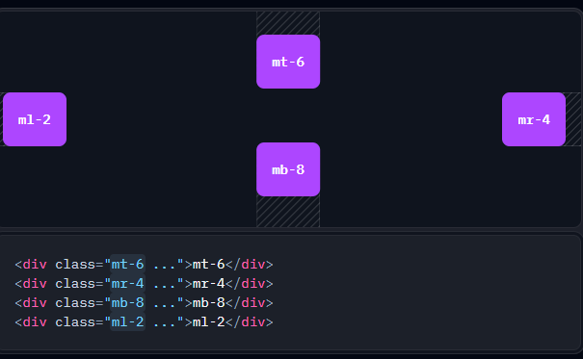
Horizontal Margins:
<div class="mx-8 ...">mx-8</div>
Verical Margins:
<div class="my-8 ...">my-8</div>

Spacing:

Use space-x-<number> and space-y-<number> utilities like space-x-4 and space-y-8 to control the space between elements
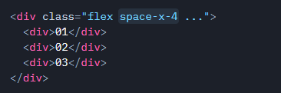

Padding:
Use pt-<number>, pr-<number>, pb-<number>, and pl-<number> utilities like pt-6 and pr-4 to control the padding on one side of an element:

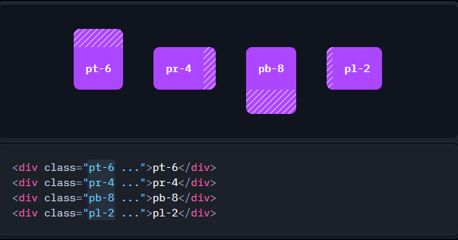

Horizontal Padding:
<div class="px-8 ...">px-8</div>
Verical Margins:
<div class="py-8 ...">py-8</div>

- Sizing:
Use w-<number> utilities like w-24 and w-64 to set an element to a fixed width based on the spacing scale
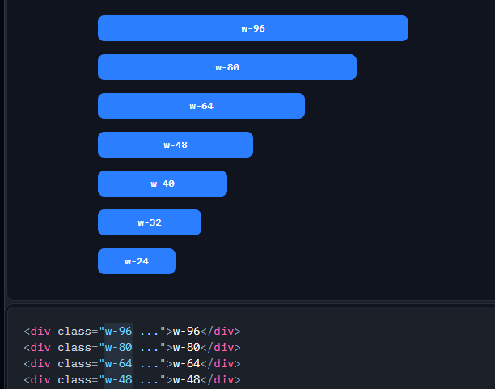

Container Scale:
Use utilities like w-sm and w-xl to set an element to a fixed width based on the container scale
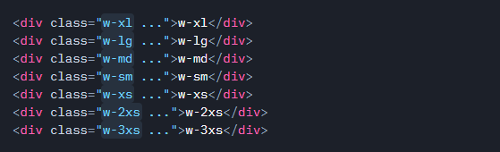

- Flexbox & Grid (Layout):

Horizontal flex:
<div class="flex">
<div class="bg-red-500 p-4">Item 1</div>
<div class="bg-green-500 p-4">Item 2</div>
<div class="bg-blue-500 p-4">Item 3</div>
</div>
Vertical flex:

<div class="flex flex-col">
<div class="bg-red-500 p-4">Item 1</div>
<div class="bg-green-500 p-4">Item 2</div>
<div class="bg-blue-500 p-4">Item 3</div>
</div>

- Responsive Design
Tailwind provides responsive design classes out-of-the-box. You can target different screen sizes using the prefix for each breakpoint:
- sm: for small screens.
- md: for medium screens.
- lg: for large screens.
- xl: for extra-large screens.
Applied to medium breakpoint or large
<div class="bg-blue-500 text-white p-4 md:bg-green-500 lg:bg-red-500">
This box changes color based on screen size.
</div>

TASKS
- Create an interactive portfolio using Css Tailwind .

- Create a modern sign up and login page using tailwind css and Bootstrap
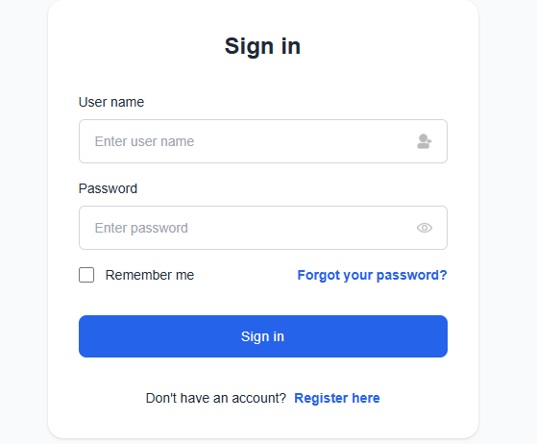

- create a todo list similar to the one given.
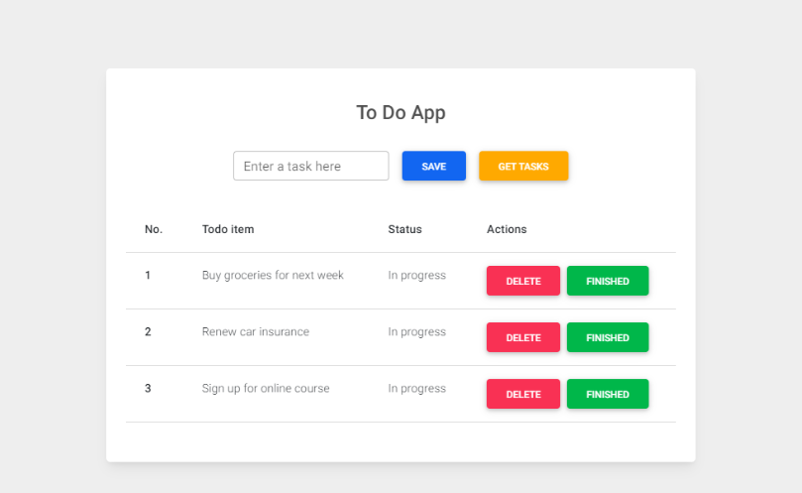
- create below given pricing chart
